## 

## E-project

## 

## Batch Code

PR2-202407D

## Group Members

|  |  |  |
| --- | --- | --- |
| Serial Number | Enrollment Number | Student Name |
| 1 | 1583601 | Muhammad Layan |
| 2 | 1585232 | Syed Adil Khalid |
| 3 | 1583605 | Syed Ali Raza |
| 4 | 1583494 | Syed Irshad Ali |
| 5 | 1582902 | Abdul Rehman |

# **ACKNOWLEDGEMENT**

## 

The first, we would like to express my special thanks of gratitude to Our Ex Teacher **Muhammed Aqueel**, & current teacher **Sir Maaz** who helped us a lot in finalizing this project within the limited time frame, valuable counselling and assistance for the accomplishment of this project.

Secondly, we would also like to thank the e-Project team at Aptech Head Office, who gave us the golden opportunity to do this wonderful project about brand of Chairs and thirdly, we also thank the e-Project team, some of the benefits are as under:

* Re-enforcement of skills happens in the experiential learning process.
* A mentor, ensuring that we do not get drifted, constantly guides us.
* It gives us a lot of confidence to face an interview as we have worked on a project. We can explain virtually everything on the subject we have learnt.

**SYNOPSIS**

With the strong growth of the internet and the increasing demand for beauty products, every business needs an effective website to showcase their products online.

1. Our Haircare website is designed with a variety of designs, styles, fonts, and layouts to appeal to a wide range of customers.
2. We offer multiple brands, each with different categories, covering a range of haircare needs, from shampoos and conditioners to hair treatments and styling tools.
3. The most special suggestion from our brand is personalized recommendations tailored to your unique hair concerns, whether it’s frizz control, color protection, or volume.
4. Our products offer the best quality within your budget, ensuring that you get premium haircare without overspending.
5. Purchases can be made directly from the website and delivered to your doorstep for maximum convenience.

# **PROBLEM STATEMENT**

**The Haircare Website** is designed to be stylish, user-friendly, and efficient, offering both beauty and functionality. The site incorporates helpful user guides and answers frequently asked questions to address customer concerns.

**Haircare products** are carefully selected to combine luxury with practicality. Just like a well-designed chair, our haircare products are meant to not only look appealing but also provide real benefits. When choosing haircare products, the ingredients are as important as the brand. The right shampoo, conditioner, or treatment can make all the difference in hair health, comfort, and appearance.

The materials and ingredients in our products determine their effectiveness and how they interact with your hair. Comfort and effectiveness go hand in hand—our products are designed to provide the best care for your hair while ensuring they feel great on your scalp.

**Haircare is for everyone**. Whether you’re looking for products for your children, a professional setting, or at-home care, we offer a range of solutions for all ages and hair types. **The Haircare Website** provides detailed product information, helping customers make informed choices about their haircare routine.

**Website Development Requirements**:

* The site will be built for the Windows platform, using **HTML, CSS, BOOSTSTRAP, JQUERY,** **JavaScript**, and to provide a seamless experience.
* It will be compatible with all leading browsers, including **Chrome**, **Internet Explorer**, and **Firefox**.
* A user-friendly design, informative guides, and direct purchases will enhance the shopping experience, ensuring that customers can find and buy haircare products with ease.

# **Requirement Specification:**

The Web site is to be created based on the following requirements.

1. Home page with suitable logo and images, making use of sections.

2. Categorized menu which will include various categories as type of treatments vailable for various different hair problems like

a. Hair loss

b. Graying

c. Growth related

d. Premature baldness etc

3. The site should also include the various easy home remedies that can be

helpful in dealing with various hair related issues

4. There should be a section which will provide the details of hair care

equipments like

a. Dryers

b. Straightners

c. Spray bottles

d. Steamers

e. Massagers

f. Spa caps

5. There should also be a section for hair care products as

a. Hair cream

b. Shampoo

c. Conditioners

d. Masks

e. Serums

f. Hairsprays

g. Various hair oils

6. Along with the various equipments, there should also be user

manual/guidelines for ease of its use and maintenance.

7. The site should also include the details as of which companies provide which

Equipments

8. Comparison among the same equipment of different companies should be

possible based on availability, cost major features

9. Gallery section should include most common instruments along with their

necessary details.

10. There should be a section which will enable user to know latest developments in the field

11. Contact us page: contact us details with location should be displayed using

GeoLocation API (eg. GoogleMaps).

12. Navigation needs to be smoother.

13. The look and feel of the project must be made user friendly and uniformity in the color combination must be maintained

**Hardware/ Software Requirements**

.***Hardware***

* A minimum computer system that will help you access all the tools in the courses is a Pentium 166 or better.
* 64 Megabytes of RAM or better Software Notepad/HTML editor VS-Code IE 5.0/ Netscape 6.0.

***Software:***

* Notepad/Html Editor.
* Dreamweaver
* IE 5.0/ Netscape 6.0

# **Objectives of the project**

The Objective of this program is to give a sample project to work on real life projects. These applications help you build a larger more robust application.

The Objective is not to teach you /JavaScript//HTML but to provide you with a real-life scenario and help you create basic applications using the tools.

You can revise the chapters before you start with the project.

This project is meant for students who have completed the module of W3 School. These programs should be done in the Lab sessions with assistance of the faculty if required.

It is very essential that a student has a clear understanding of the subject. Students should go through the project and solve the assignments as per requirements given.

Kindly get back to eProjects Team in case of any doubts regarding the application or its objectives.

# **SCOPE OF THE WORK**

1. **Platform & Technologies**:

* Platform: The website will be developed for the Windows platform.
* Technologies Used: The website will be built using HTML, JavaScript, and jQuery Bootstrap 5.
* Browser Compatibility: The website will be compatible with all leading browsers, including Chrome, Internet Explorer, Firefox, and others.

2. **Homepage Design & Features**:

* **Product Showcase**: Feature top-rated haircare products prominently, including best-sellers and popular items from categories like:
  + Shampoos
  + Conditioners
  + Hair Treatments
  + Styling Tools
* New Collection: Display new arrivals or seasonal collections to keep the product offering fresh.
* Shop Now Button: A prominent call-to-action button that guides users to shop by category (e.g., For Dry Hair, For Oily Hair, etc.).
* Haircare Solutions: Highlight targeted solutions for specific hair issues like:
  + Frizz Control
  + Color Protection
  + Volume Boost

3. **Product Pages**:

* **Detailed Product Information**: Each product page will include:
  + Comprehensive descriptions
  + Ingredients
  + Usage instructions
  + Customer reviews
* **High-Quality Images**: Showcase products with high-resolution images to enhance the user experience.
* **Pricing & Availability**: Clearly display:
  + Pricing
  + Availability
  + Stock information
* Add to Cart: Users can easily add products to their cart with a straightforward button.

4. **Shopping Cart**:

* **Shopping Cart**: Users can view and manage products in their cart:
  + View product quantities
  + Modify quantities or remove items
  + Proceed to checkout

5. **Remedies Page**:

* **Remedies Information**: A dedicated page offering remedies for common hair problems:
  + Natural hair care tips
  + Home-made solutions for hair issues like dry scalp, hair fall, etc.
  + Expert advice or a consultation option

6. **Blog Page with Latest Developments**:

* **Blog**: A blog section with regular updates on:
  + The latest developments in the haircare industry.
  + Product reviews, hair care tips, and expert advice.
  + Company Details: Information about the company’s growth, initiatives, and new product launches.
  + Previous Trends: A historical overview of product trends, and notable advancements in haircare technology.

7. **Dynamic Product Detail Page**:

* **Product Detail Page**: Each product detail page is dynamic and will be updated regularly to reflect:
  + Current promotions
  + Availability updates
  + Customer reviews
  + New ingredients or features

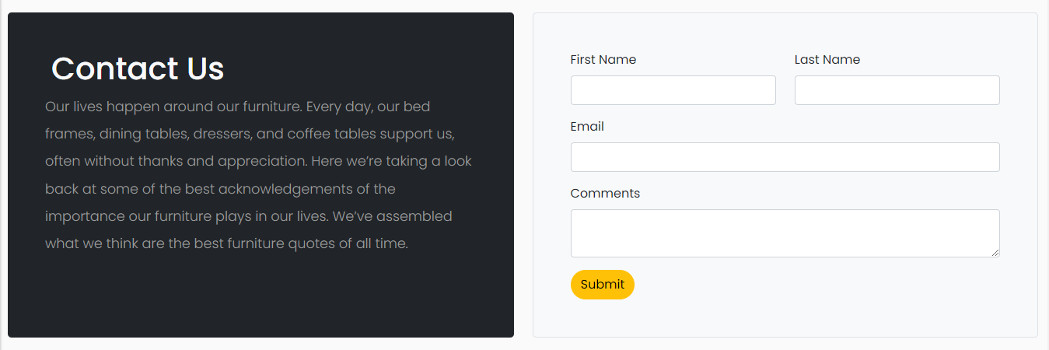

## WIRE FRAME

1. **Main Layout**

**Logo**

**Navbar**

**Background Image**

**Button**

**Text**

Products

**Img**

**Text**

**Img**

**Text**

**Img**

**Text**

**Products**

**Img**

**Button**

**Img**

**Img**

**Img**

**Img**

**TEXT**

**Text**

**Image**

**Button**

**Form**

**TEXT**

**Text**

**Submit**

**Footer**

z

## Text Sheet Review

|  |  |  |  |
| --- | --- | --- | --- |
| **Serial Num** | **Names** | **Project Title** | **Task** |
|  | Muhammad Layan | Hair care | Home Page , Product Page , Remedies Page , Product Detail Dynamic Page , Blog Page , Compare Page , Cart page, Javascript And More |
|  | Syed adil khalid | Hair care | Contact Page, footer  Eproject documentation |
|  | Syed raza ali | Hair care | About page, blog section |
|  | Abdul rehman | Hair care | Logo , Cards |
|  | Syed Irshad | Hair Care | Accordian |